SOP Database

The SOP Database is called Virtuoso. As the ELL teacher you will need to add the LEP page for each language minority student in a timely manner. The following students must have an LEP page in Virtuoso:
- Student who was born in another country
- Student who reports another language spoken in his/her home
- Student who reports a home language other than English

Please use the SOP Home Language Survey as your guide.

https://virtuoso-sis.cinglevue.com/f?p=2212520080618:1

- Login. If you get an error message, DO NOT keep trying. You will be locked out after 3 attempts. Please contact Darline Wilder (dwilder@richmond.k12.va.us) if you forget your login information.

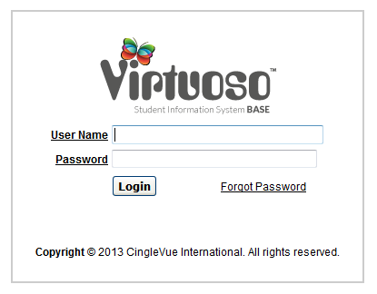

- Check to make sure the Role field shows ESL Teacher. If it doesn’t, use the pull down menu to select it and then click, “Go”

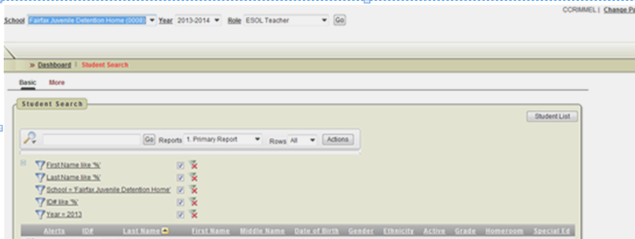

- Choose “All” from the menu, so you can see all the student names.

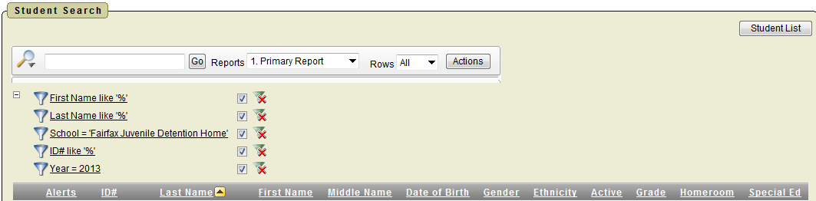

- Clicking the pencil in front of the name of the language minority student will take you to the demographics page.

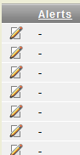

- Choosing LEP on the pull-down menu and pressing go will take you to the LEP page.
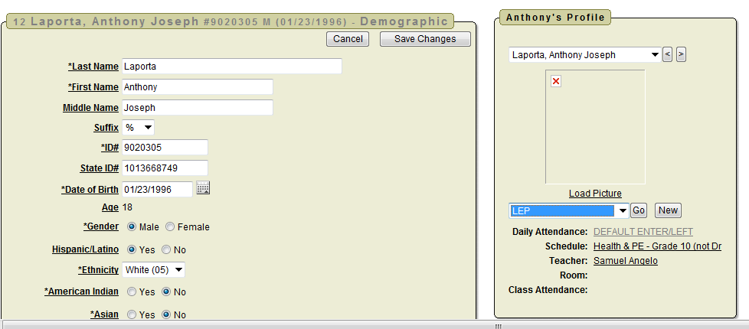

- Choose “Create”.

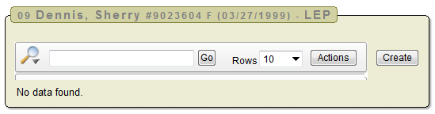

- Complete the LEP Information and Click “Create”.

- Status Date: Use the entry date into the school program. This needs to be updated if the student returns during the year.

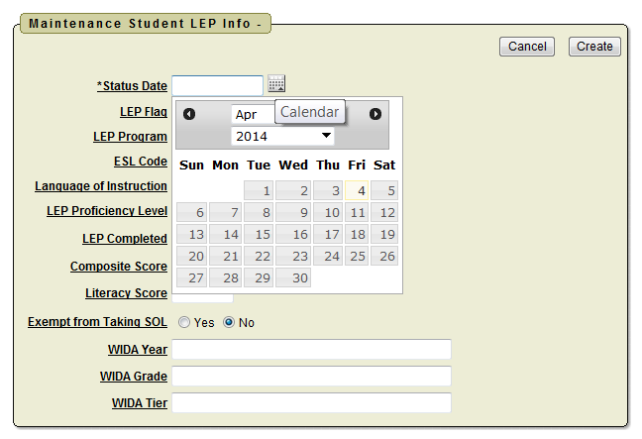

- LEP Flag: Choose “Yes” for ELP Levels 1 – 5. Choose “Former LEP student” for level 6. Choose “No” for language minority students who do not qualify for ESL. DO NOT USE Monitored.

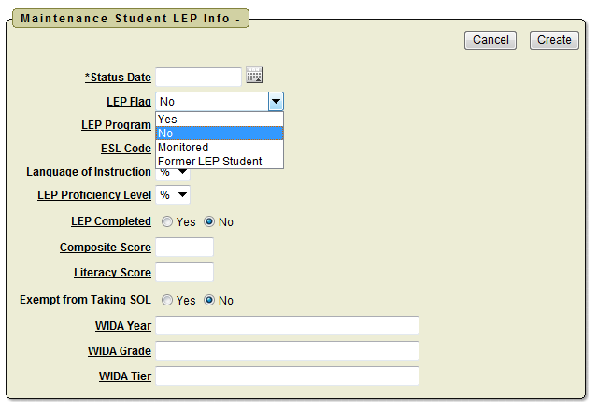

- LEP Program: Choose “1” for students who are in the ESL program. Choose “2” for students who could receive ESL services, but their parents refused services for them. Choose “3” for Level 6 FLEP students. Leave it blank if the student has exited from the ESL program or never qualified for ESL.

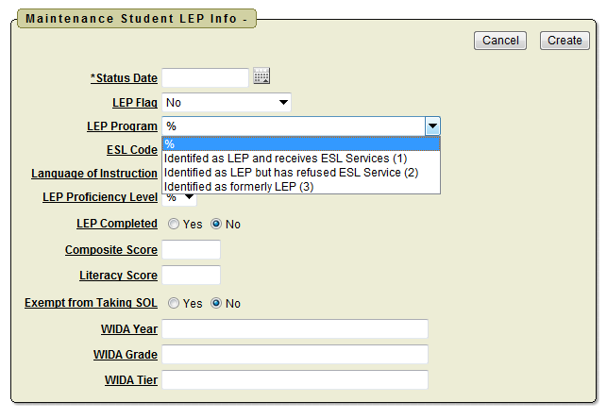

- ESL Code: Choose “1” for students who are in the ESL program. Choose “2” for students who could receive ESL services, but their parents refused services for them. Choose “3” for Level 6 FLEP students. Leave it blank if the student has exited from the ESL program or never qualified for ESL.

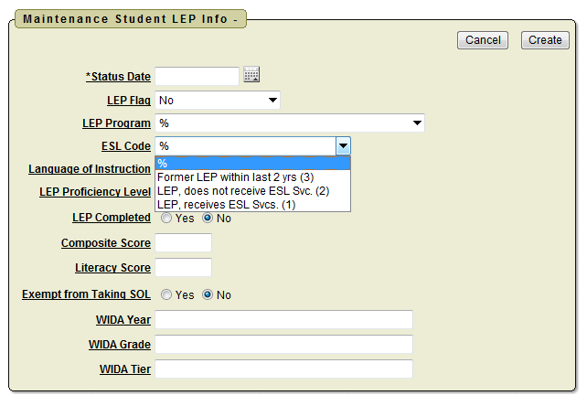

- Language of Instruction: Choose “English (400)”. Note: There may be some exceptions to this at Northern Virginia JDC or Shenandoah JDC.

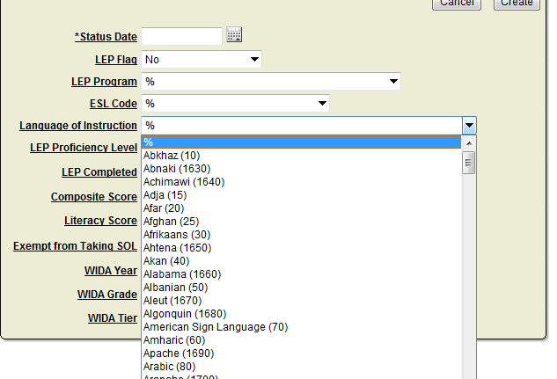

- LEP Proficiency Level: Choose the English Language Proficiency Level. Leave it blank for students who are not in the ESL program.

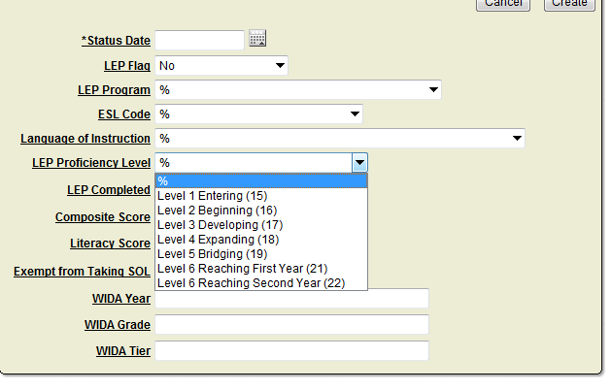

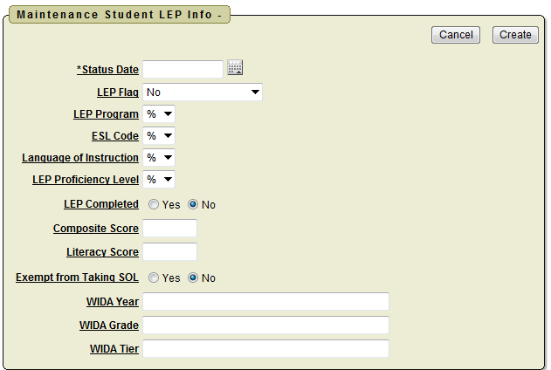

- LEP Completed: Default is no. Choose “Yes” if the student used to be in ESL AND has finished two years at ELP Level 6. Note: If the student never qualified for ESL, do not change the default. This is only to show students who completed the ESL program.

- Composite Score: Use a current WIDA ACCESS, MODAL, or W-APT score. DO NOT USE the decimal point. For example if the student has a composite score of 1.5, write in 15. If student is LEP, but there is no current score use 99.

- Literacy Score: Use a current WIDA ACCESS, MODAL, or W-APT score. DO NOT USE the decimal point. For example if the student has a composite score of 1.5, write in 15. If student is LEP, but there is no current score use 99.

- Exempt from Taking SOL: SKIP THIS ITEM.

- WIDA Year: If the student has a current ACCESS score, write in the first year of the current school year. Example, 2013-2014, should be added as 2013. If the student has a current MODAL OR W-APT score, write in the complete date. Example, 12/13/2013. LEAVE THIS BLANK IF THERE IS NO CURRENT SCORE.

- WIDA Grade: If the student has a current ACCESS score, write in the first grade level of the WIDA ACCESS test. Example, Grade level 6-8, write in 6. If the Grade Level is 9-12, write in 9. . LEAVE THIS BLANK IF THERE IS NO CURRENT SCORE.

- WIDA Tier: If the student has a current ACCESS score, write in the tier: A, B, or C. . LEAVE THIS BLANK IF THERE IS NO CURRENT SCORE.

- Click Create to finish the process.

Multiple students: You can create LEP pages for several students quickly, by changing names using the pull down here. Don’t worry that it says “Auxillary” in the other box. It will still take you to the LEP page. It’s much faster than returning to the main page and clicking on the pencil each time.

